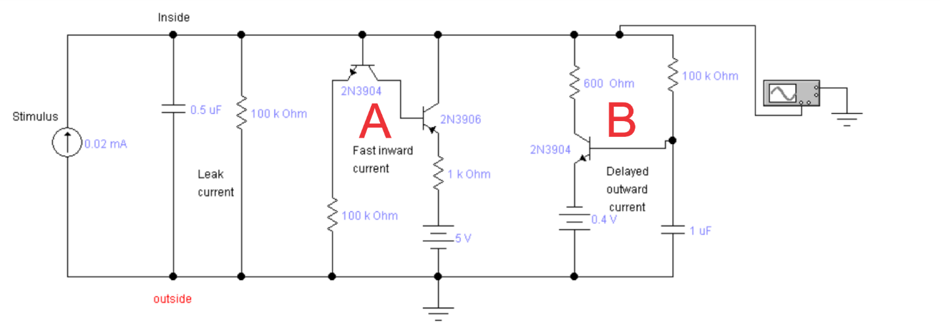

Let’s consider transistor sub circuits A and B as ideal switches. When we just turn on the current source, the upper node voltage is equal to 0. Both switches are off, and the circuit could be reduced to the following circuit

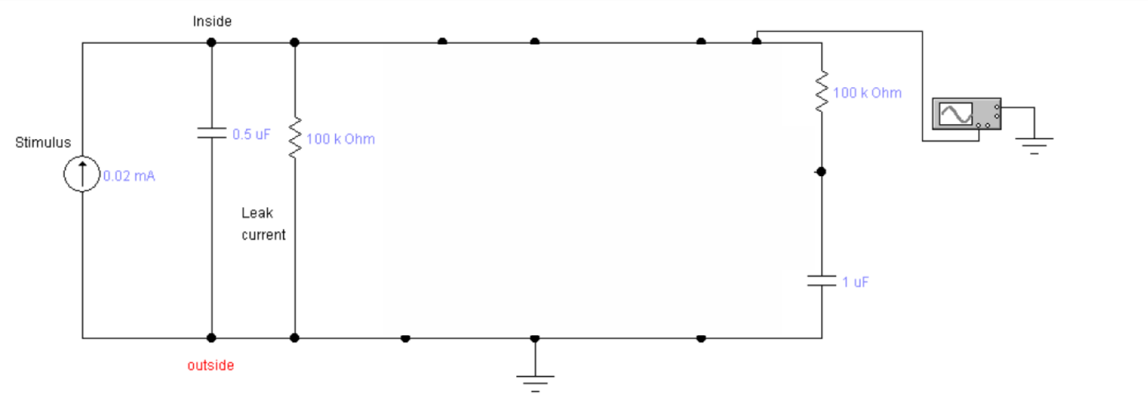

The dynamic of the upper node $V(t)$ depends on the values of capacitors and resistors, but the final (equilibrium) voltage depends only on the stimulus current $I$ and leak current resistor. If we are not interested in dynamics of $V(t)$, but only in it’s equilibrium value, we can remove capacitors from the circuit.

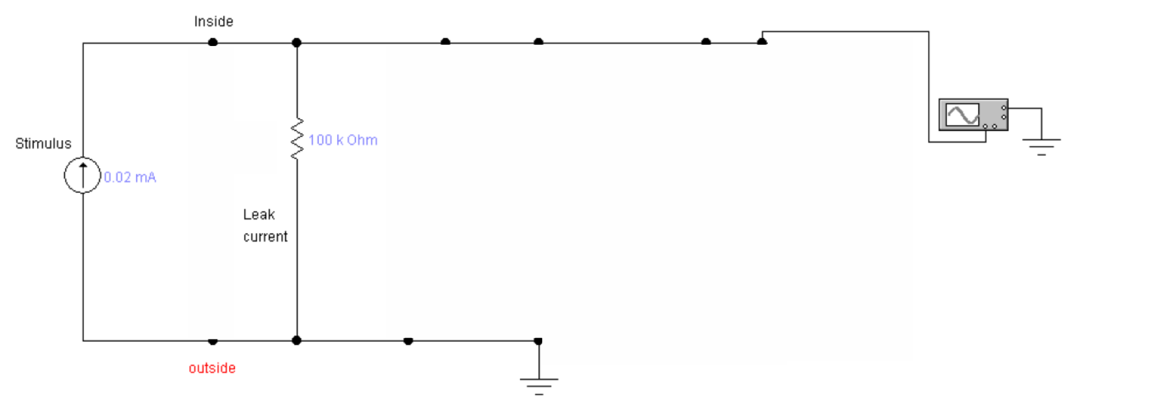

**Find the voltage at the top node for this circuit.**

Now let’s turn on switch A

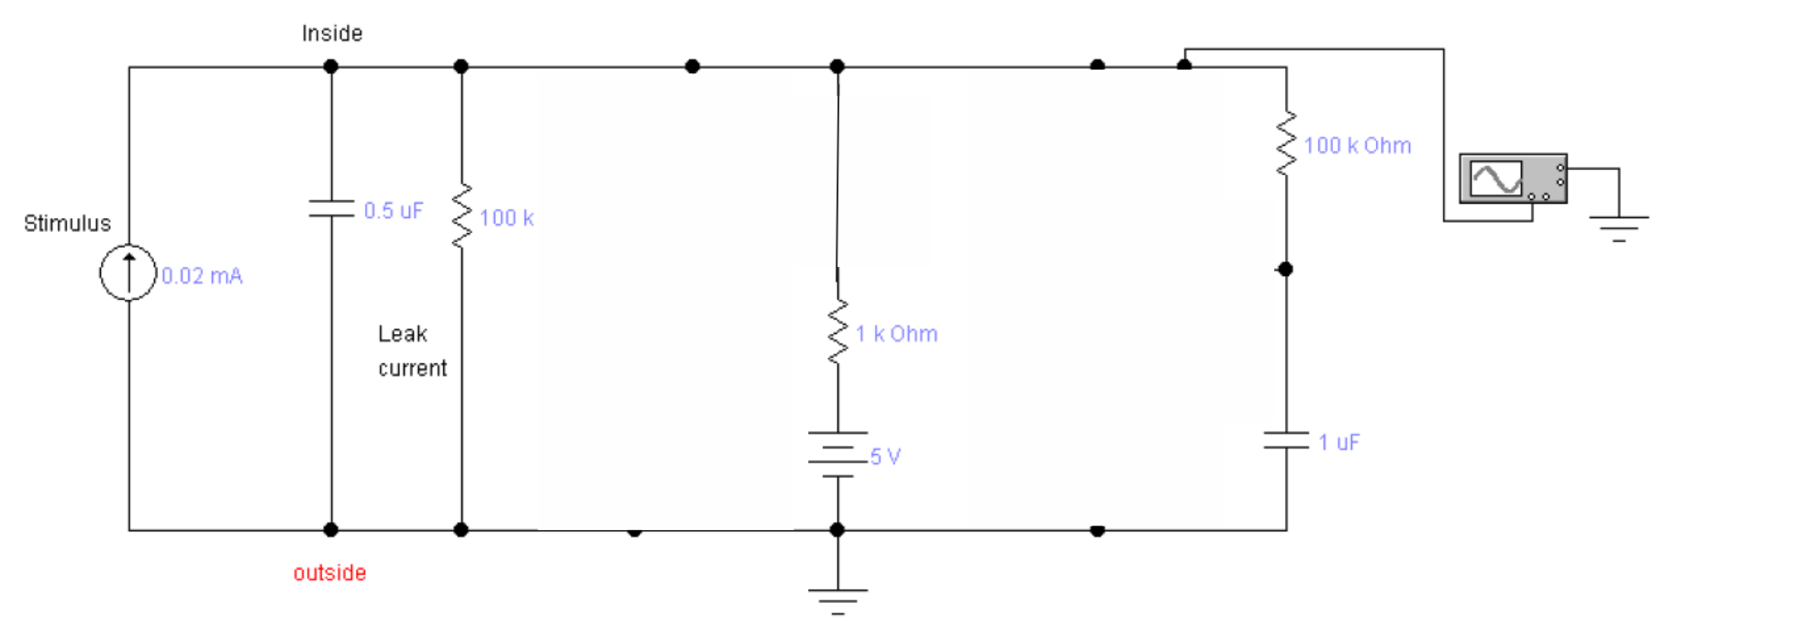

If we again are not interested in dynamics of $V(t)$, we can redraw the circuit dropping all capacitors

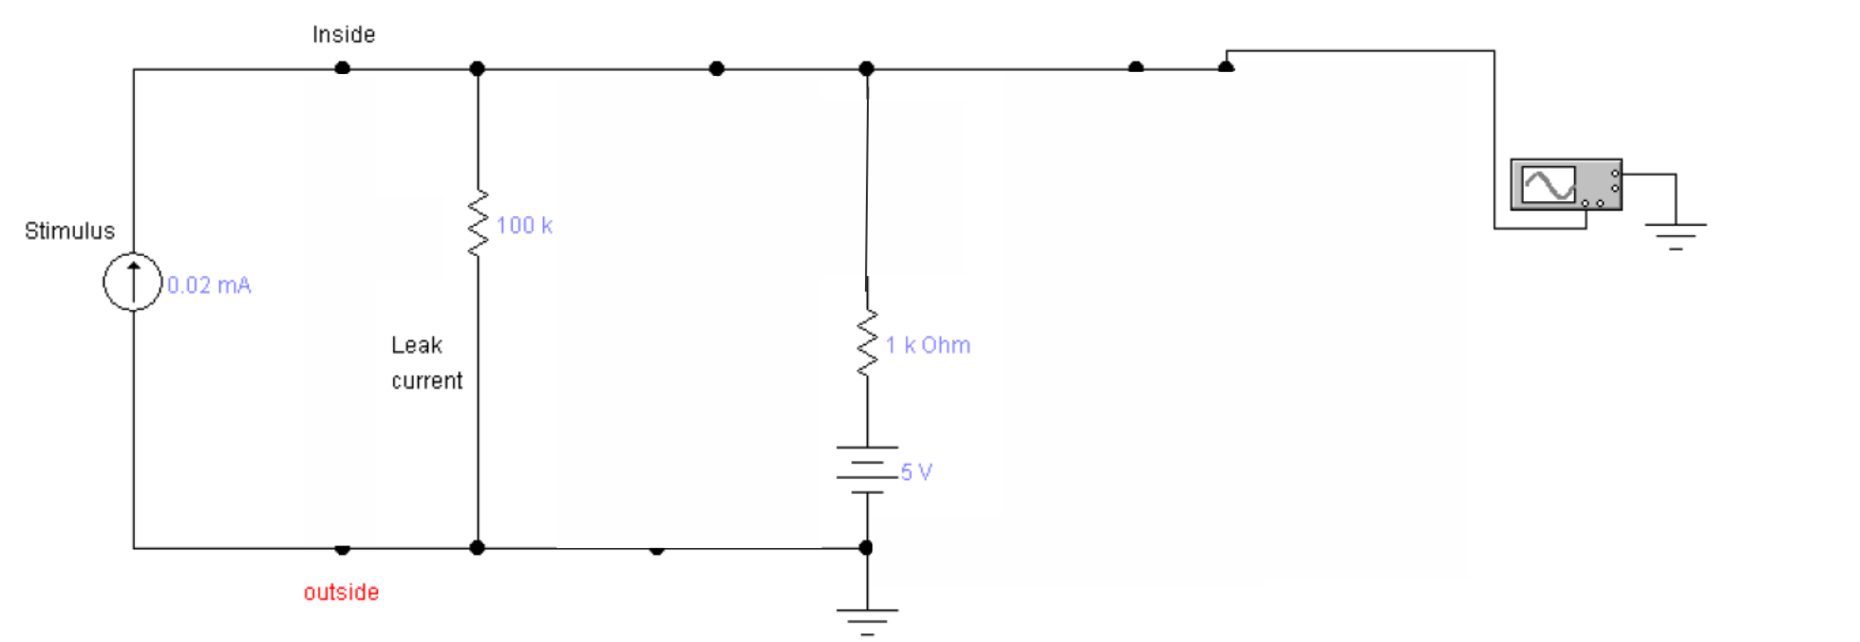

**Find the voltage at the top node for this circuit.**

And finally let’s turn on the switch B

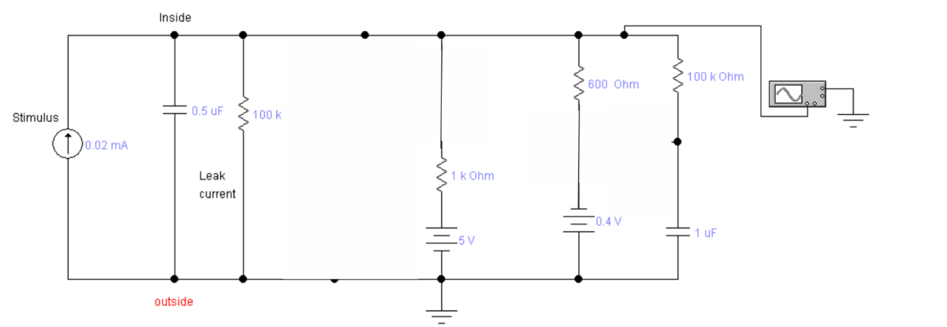

and drop all capacitors again

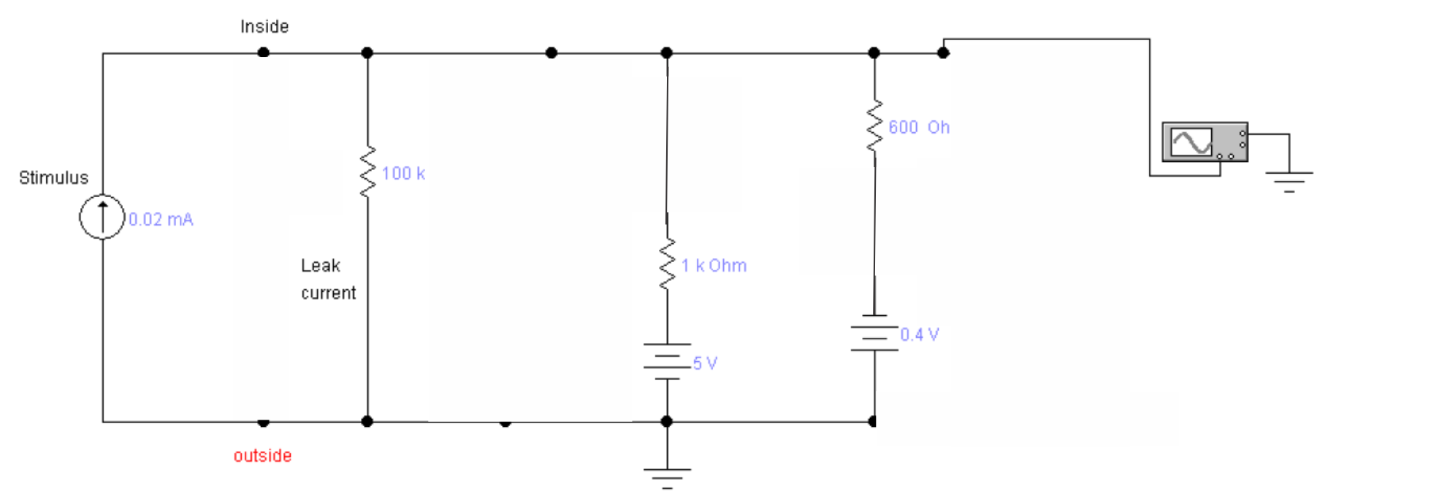

**Find the voltage at the top node for this circuit.**